Project Report

On

**Unveiling The Virtual Classroom: An In-Depth Analysis Of The Online Education System**

Submitted

In fulfilment of the requirement of

**Faculty Buildathon 2023**

Submitted by Submitted to

Dr. Jatin Arora IBM SmartInternz

Chitkara University Buildathon

Punjab

**Content**

**1  INTRODUCTION**

1.1 Overview  
A brief description about your project

1.2 Purpose  
The use of this project. What can be achieved using this.

**2  LITERATURE SURVEY**

2.1 Existing problem  
Existing approaches or method to solve this problem

2.2 Proposed solution  
What is the method or solution suggested by you?

**3  THEORITICAL ANALYSIS**

3.1 Block diagram  
Diagrammatic overview of the project.

3.2 Hardware / Software designing  
Hardware and software requirements of the project

**4  EXPERIMENTAL INVESTIGATIONS**

Analysis or the investigation made while working on the solution.

**5  FLOWCHART**

Diagram showing the control flow of the solution

**6  RESULT**

Final findings (Output) of the project along with screenshots.

**7  ADVANTAGES & DISADVANTAGES**

List of advantages and disadvantages of the proposed solution

**8  APPLICATIONS**

The areas where this solution can be applied

**9  CONCLUSION**

Conclusion summarizing the entire work and findings.

**10  FUTURE SCOPE**

Enhancements that can be made in the future.

**11 BIBILOGRAPHY**

**1. Introduction**

Now a days online learning education takes place over the internet. In the pandemic situation students started learning at online platform. Many educational systems changed in the pandemic situation and somethings affected student education life. Students were studying on black boards in the school but now they are used to white board on the white screen. Is often referred as “e- learning” among other term. However online learning is just one of the type of “distance learning”. All are facing problems related to health, finance, nowadays. In this pandemic situation some people lost their jobs. The financial condition during these days was not good as well.

**1.1 Overview**

During the pandemic condition, online education system started. With this helps schools where going on with the help of apps such as zoom, Google meet, YouTube and other. But this process of learning made some of the parents uncomfortable. Before these situations arrived it was always a big-time debate regarding which is better online classes or offline classes and now that almost all schools and colleges are using online modes for teaching, there are many points of view regarding the same, positive as well as negative.

With the help of science, we can get information about any place in one fell swoop, whether it is at home or not, with the help of internet only. The advances that science has made can now be used in a large way in the field of education as well. The same thing applies with e-learning. But the parents who paid their children’s school fees by taking out a bank loan were facing a financial crisis. Bring electronic items like mobiles, tabs etc. to your children to attend online lectures. For many it was affordable, but for many it was unaffordable. But not wanting to stop their children’s education, the parents also decided to change their minds and adopt this new method of education.

1.2 Purpose

The purpose of this study is to acquire knowledge from all around and to develop our best analysis out of it. Nothing else can be as useful as technology for this. Online education has taken the next step in development and opened up a wealth of knowledge for students and teachers. The impact of online education on students’ performance and the usage of electronics devices impacted very hard on the grades in exam. The internet connectivity issues also added additional burden on the students and parents. Social media usage by the students also created a challenge for teaching community to handle the student’s interest. The sleep time and study time of student also played an important role in achieving the required performance. Finally the satisfaction of student is also required to be analysed for the betterment of the online education system.

**2.  LITERATURE SURVEY**

Both teachers and students may like the work-from-home online education method, but can digital education be a permanent cure, as it is an alternative in today’s difficult times? Along with academic development, physical and mental development is also very important for the overall development of the student.

Traditional learning holds the use of conventional learning tools comprising of blackboards, chalks, books and pens. Confined within the walls of classrooms, students acquire education from teachers present in the classroom and get direct assistance from them in the time of inconvenience or doubts regarding the subject. Enrolled to the institution for a specific term or period, the students attend classes every day. With advent of technology, those boring blackboards were replaced by white boards and markers, and projectors were used to make teaching interesting. Aligned With Audio Visual Display – As the learning was becoming complex, use of audio visuals, power point slides, digital boards was aligned with the other teaching pedagogies.

2.1 Existing problem

As with most teaching methods, online learning also has its own set of positives and negatives. Students were disciplined while in school. Listen carefully while teaching and write down what the teacher says. But now the children have become so smart that they attend school wearing uniforms and shorts. Practical experience and demonstrations are very important for education. There is a dearth of demonstrations in online education. At school students study by observing physical objects but in this online learning animated video is used.

Due to the online learning method, children have to spend a lot of time in front of this screen. If they are only learning six hours in school, then they have to spend more than six hours at home for this online learning. Children who live in rural areas have to deal with many problems such as video interruptions and deafness due to network problems. There are many challenges that come not only to students but also to parents. I have chosen this subject to understand the problems of students as well as parents. So that I can understand that online learning methods are a curse or a blessing.

Now technology has become an important part of their lives. And with this technology, kids are spending more and more time in front of this screen. This has made the difference in their health a part of their parents’ concern. If a student is completely dependent on technology while still a student, he will not be able to do anything on his own. But with this medium of e-learning, students have to constantly sit in front of the screen and make maximum use of it.

Students are not able to focus on teaching more. So this effect is reflected in their study. Students are falling short of assimilating what teachers are teaching. Which shows a lack in their confidence. This is a preliminary step and students should be encouraged to study with confidence by taking timely measures.

Not only mental health, but they are also facing some health problems like eye strain, headaches and fatigue from seeing the screen for such a long time. Besides, sports education and extracurricular classes have also stopped.

2.2 Proposed solution

The children of the present age are very modern. If something new comes up, they try to absorb it quickly. They are trying to assimilate the current e- learning. Today’s generation is techno-savvy. So they assimilate all the types related to technology as soon as possible. They are actively using technology to learn on multiple devices, and appreciate high-value, engaging, interactive, on-demand course materials and support, anytime and anywhere. Every generation has something new. Every child has the hope of learning something new according to the generation. Analysis of online education system should be made to handle the impact of various factors such as sleep time, study time, social media, device type and many more.

**3  THEORITICAL ANALYSIS**

Surveys are conducted to gather information about a population. Sometimes the survey is conducted with the goal is to survey every unit in the population. However, it is frequently impractical or Impossible to survey an entire population, perhaps owing to either cost constraints or some other practical constraint, such as that it may not be possible to identify all the members of the population. An alternative to conducting a survey is to select a sample from the population and survey only those sampled units.

3.1 Block diagram

Given the current situation, online education is a need of the hour. But its impact on students is the next big problem facing the country. So can we contribute something in our own way. So that the problems faced by the students are known to all. And there will definitely be efforts to find a way out of this. The block diagram is shown in Fig. 1.

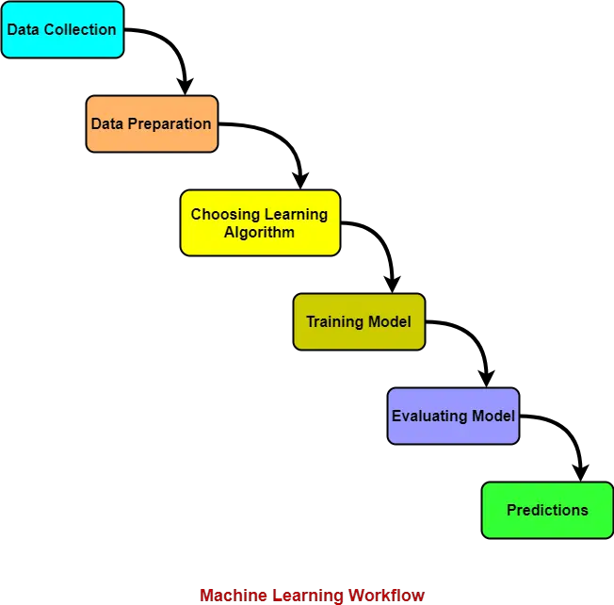  
Fig. 1. Block diagram of Online education system analytics

3.2 Hardware / Software designing

|  |  |
| --- | --- |
| **Requirement** | **Specification** |
| Operating system | Microsoft Windows  UNIX  Linux® |
| Processing | Minimum: 4 CPU cores for one user. For each deployment, a sizing exercise is highly recommended. |
| RAM | Minimum 32 GB. For more information, see [Memory settings](https://www.ibm.com/docs/en/SSEP7J_11.1.0/com.ibm.swg.ba.cognos.inst_cr_winux.doc/c_installs_verify_ram.html). |
| Operating system specifications | File descriptor limit set to 8192 on UNIX and Linux |
| Disk space | A minimum of 7 GB of free space is required to install the software and 5 GB of free space on the drive that contains the temporary directory used by IBM Cognos components.  An environment variable points to the temporary directory. On Windows this variable is TMP. On UNIX and Linux, this variable is IATEMPDIR  For all databases, the size will increase over time. Ensure that you have sufficient disk space for future requirements. |
| Printer | To ensure that reports print properly on Windows, Adobe Reader requires that you configure at least one printer on the computer where you install the Application Tier Components. All reports, regardless of the print format that you choose, are sent as temporary PDF files to Adobe Reader for printing. |
| Email server | To email reports, the system requires the ability to use and access an email server. |

|  |  |
| --- | --- |
| **Requirement** | **Specification** |
| Java™ Runtime Environment (JRE) | An IBM JRE is provided as part of the install with IBM Cognos Analytics on all operating systems. |
| Database | You must have one of the following databases available to store IBM Cognos data:   * Oracle * IBM Db2 * Microsoft SQL Server * Informix®   The Easy (previously Ready to Run!) option installs and configures an Informix database as the content store.  TCP/IP connectivity is required for all database types. |
| Web browser | For all Web browsers, the following must be enabled:   * cookies * JavaScript |

**4  EXPERIMENTAL INVESTIGATIONS**

Analysis or the investigation made while working on the solution.

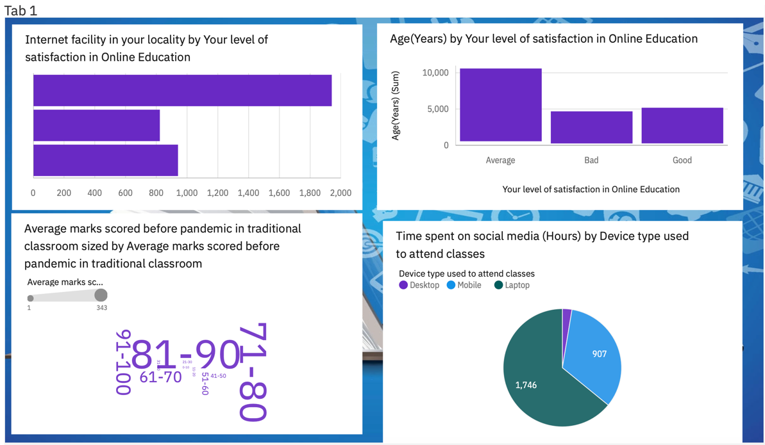

Fig. 2. Dashboard representing four visualizations

Fig. 3. Dashboard representing three visualizations

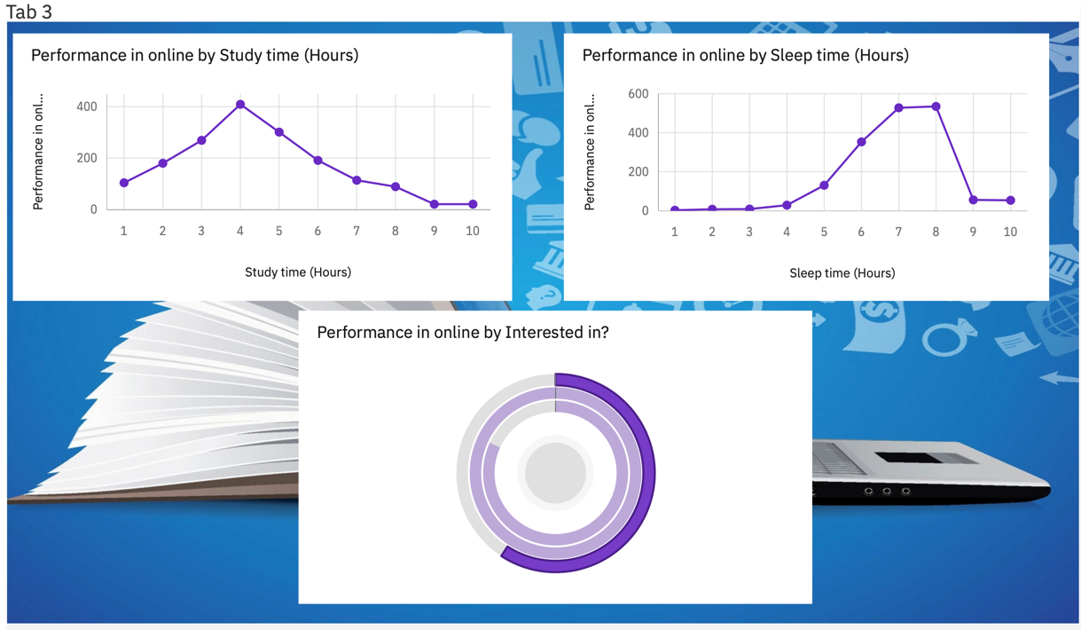

Fig. 4. Dashboard representing three visualizations

1. **FLOWCHART**

Diagram showing the control flow of the solution

Prepare Visualization

Data Cleaning

Data Uploading

IBM Cognos

Result

Prepare Analysis

Fig. 5. Flow chart of solution proposed

Students find it difficult to adapt to an online learning environment immediately after traditional classroom learning. Due to the sudden change, they are not able to adapt to the online learning. Students who have been always studying in the traditional classroom mindset are not able to focus on online platforms. It is important for them to accept the new learning environment with an open mind.

Many students are not well equipped with a high internet connection that is required for online learning. Due to this, they face problems in going live for virtual learning and other platforms that require internet connection. They face technical issues as they are not much aware of technology and computer applications. A slow and high internet connection can play an important role in how quickly you can attend the class and do not miss any live sessions. There is a possibility of poor connectivity if you find difficulty in downloading some information related to the subject.

Students lack effective communication skills during online learning. Teachers give assignments for improving reading and writing skills but there is a possibility that they might not be able to write so convincingly that educators understand the concept behind their assignments. There are some students who feel shy to communicate with their teachers and friends due to the new model of learning. It might happen due to lack of interest, poor technological skills with apps and video calls or unable to express themselves via live chats, emails or text messages.

**6 RESULT**

**Story Visualization**

Fig. 6. Story represent Time spent on social Media

Fig. 7. Story represent impact on performance w.r.t study time

Fig. 8. Story represent impact on performance w.r.t sleep time

Fig. 9. Story represent an analysis of Satisfaction of student w.r.t age

Fig. 10. Story represent an analysis of Internet facility w.r.t satisfaction in online education

**7  ADVANTAGES & DISADVANTAGES**

Above all, although E-learning has huge influence on promoting study, it is still not a perfect educational means there are still a lot of intractable problems. It does not matter E- learning import advanced technology, it cannot substitute face-to-face communication between teacher and students and students and practical activity, mention less education of thousand- year of human’ history.

There are both pros and cons of online education. Online learning should be seen as a complement and extension of classical forms of learning. Not even the best online course can fully replace the personal contact with the teacher, are the human relationships that develop in a group. All in all, traditional classes should not be replaced with online classes.

**8  APPLICATIONS**

The study of online education system helps the institutions and academician to focus on the online education challenges and improve the students performance based on the analysis. There are some major applications of the online education system analysis and are listed below.

1. Provide motivation to students based upon their performance and study time.

2. Building connection with student then they will share their problems.

3. Help students to maintain focus.

4. Sharing of inspirational stories to give them real life examples.

5. Identification of weak students and providing support to struggling students.

**9  CONCLUSION**

Education is the need of the hour. Education develops man. Man’s learning is necessary for the progress of himself as well as the country. It all started when the person was in school. The methods of teaching and learning are changing day by day. And it is in our best interests to accept all these changes. Our technology has evolved. So now it is easy to get online education.

With the help of obtain results from the previous chapter “data analysis” the current chapter is being carried out as a summary of results which formed the basis of this project. Results of the analysis are supported by appropriate literatures to explain the summarised findings.

The aim of the study is to identify the factors affecting students’ satisfaction, efficiency and performance regarding online classes during the pandemic period of COVID–19. The study is quantitative in nature, and the data were collected from 140 respondents through online survey who were studying in school.

**10  FUTURE SCOPE**

This online method often exposed the system to brass. The inadequacy of knowledge, the mere appearance of teaching, does not mean that online teaching methods will continue in the future. Even though a coin has two sides, but one side is always heavier. E-learning methods depend on many things. Such as education, students, technology, learning process, dynamic future and much more. It is important to have a joint effort. Although the teachers had difficulty in learning this online method, they endured it to make the future of the students happy. And today they are trying to teach the students through this medium, which is really very appreciated.

**11 BIBILOGRAPHY**

1. www.embibe.com
2. www.slideahare.com
3. www.researchgaresearchgate.com
4. www.microbenotes.com
5. IRRODL
6. m.saamana.org
7. southeastern.edu